Refocus Puzzle.

**How to solve:**

For Halloween this refocus puzzle was a Halloween themed wordsearch. There are 20 Halloween themed spooky words to find. Turn to Page 140 of the Autumn 2023 ***OCD Magazine*** for the solution.

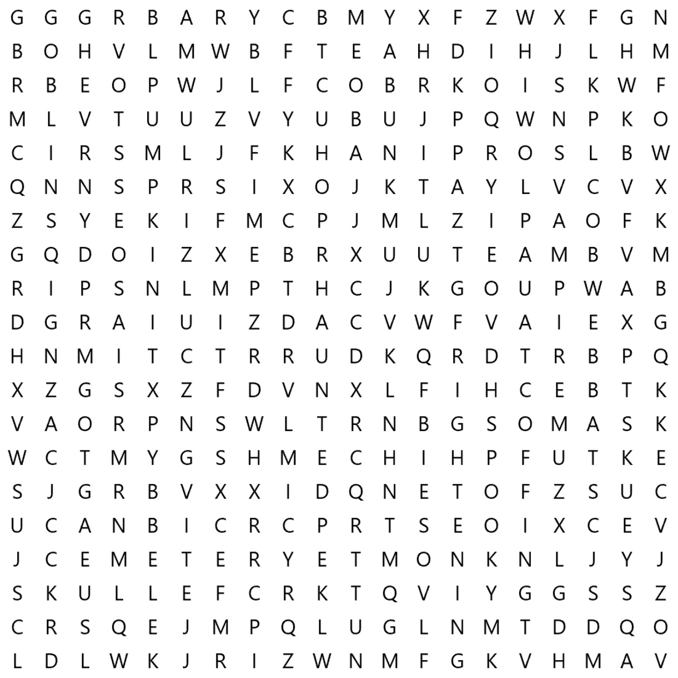

|  |  |  |  |
| --- | --- | --- | --- |
| Bats  Cemetery  Cobweb  Coffin  Costume | Dracula  Eerie  Frightening  Ghouls  Goblins | Haunted House  Mask  Night  Pumpkin  Scary | Scream  Spooky  Skull  Vampire  Zombie |

The 20 Spooky words to search for